Vermot-Desroches Matthias

Rapport de séance n°5

During this session I started by beginning the programming on the obstacle detection of the servomotors. I used the HC-SR04 ultrasound sensor with the servomotor. Here is the electrical set-up that I made:

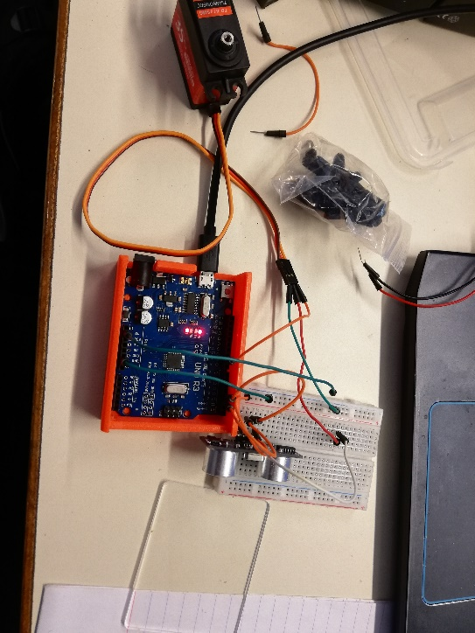

And this is the bit of programming I did:

With this script, if the echo of the ultrasound make more than 20 secondes, the servomotor rotates. It is of course not the final value nor the final version of this code, since we probably will make the robot rotate following a certain pattern or when he is close to an obstacle.

Before continuing the programming, the cutting machine became available (it was HS for the first 2 hours) and I was able to make the second part of the wooden model.

Then, I decided to change the CAD model of the wooden joint because they could not fit on both plate at the same time (the top and the bottom had a different tooth pattern).

